** Movie Hunter Application**

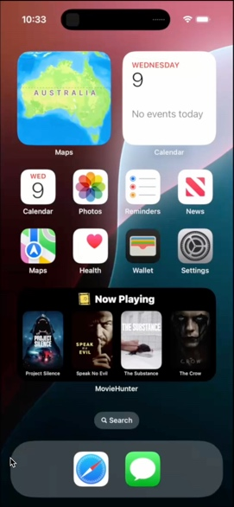Are you ready to dive into the world of movies? Find the best movie to watch with Movie Hunter!

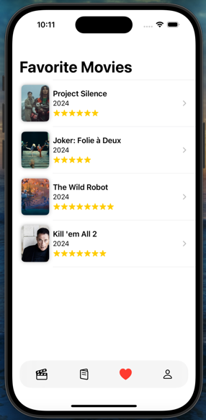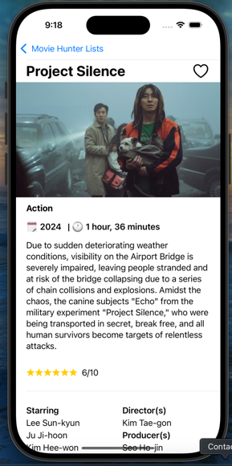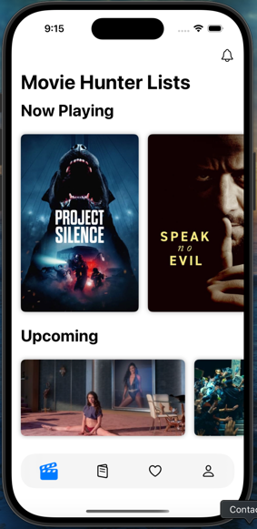

**Movie Hunter Features:**

1. **Discover Movies in Real-Time:** Stay up to date with the latest now-playing, top-rated, popular, and upcoming categories.
2. **Dive into Movie Details:** Uncover comprehensive movie information, including ratings, release year, duration, producers, cast, and even trailers, for an immersive viewing experience.
3. **Smart Search Options:** Find your next movie easily by typing a keyword or using the built-in microphone to search with your voice.
4. **Never Miss a Movie:** Add movies to your personalised reminder list to keep track of films you are excited to watch.
5. **Create Your Own Collection:** Add your favourite movies to your personalised movie library, all in one place for quick access.

**System Extensions:**

1. **Widget:** Displaying top four now playing movies

<https://developer.apple.com/documentation/widgetkit/creating-a-widget-extension/>

1. **Notification:** Notifying the user about scheduled movie reminders

<https://developer.apple.com/documentation/usernotifications>

1. **Safari extension:** Navigate to YouTube to watch the movie’s trailer.

<https://developer.apple.com/safari/extensions/>

**Error Handling Strategy:**

The Movie Hunter application has a MovieError Enum, which defines various types of errors that may occur, each associated with a specific error message. This enum aims to streamline error handling throughout the application by providing descriptive error cases that can be used in guard-let statements. When there is an error, the appropriate case from MovieError is thrown instead of using generic error handling (see the picture below as one example).